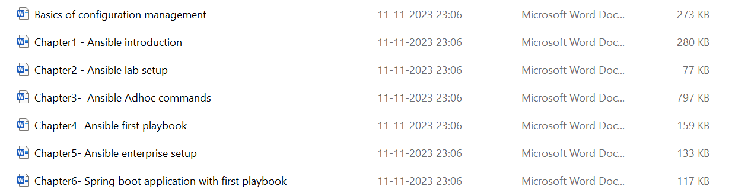

Chapter7: Playbook with variable.

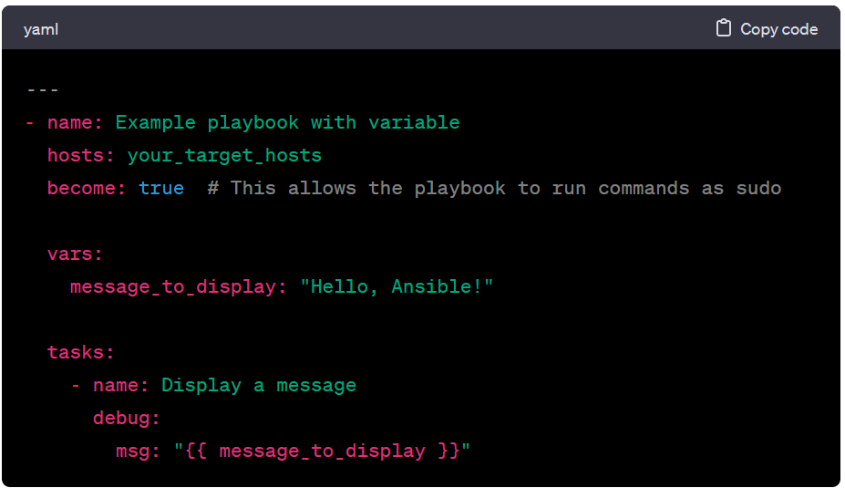

Chapter8: Group var and host var

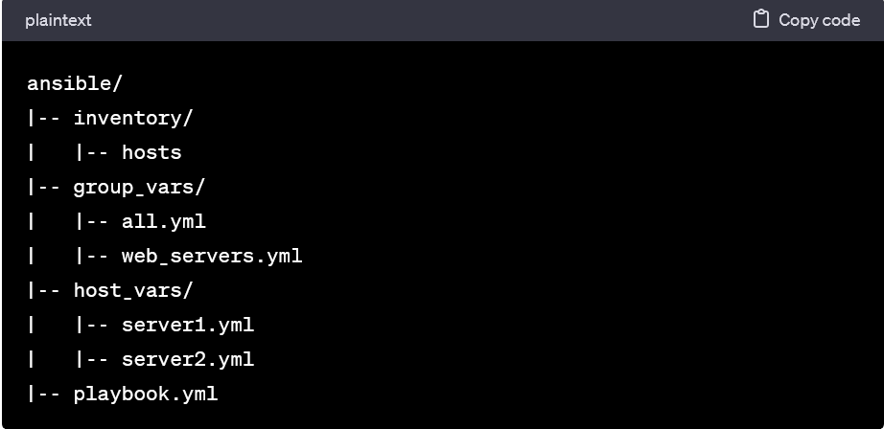



Chapter11: Loop and ansible

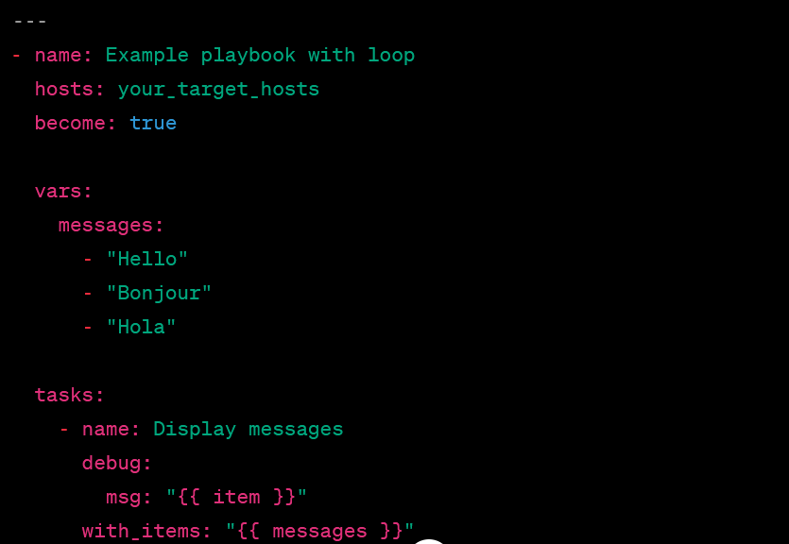

Ansible role: In Ansible, a role is a way to organize and structure your Ansible content. Roles provide a framework for breaking your playbooks into smaller, reusable components. A role is essentially a collection of variables, tasks, handlers, files, and templates that can be easily shared, reused, and executed.

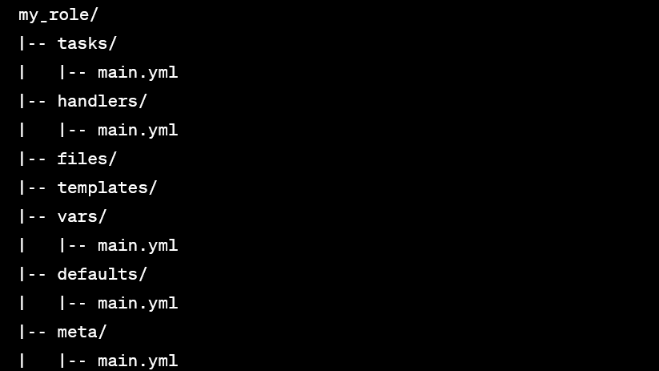

Ansible collection: An Ansible Collection is a distribution format for Ansible content, including roles, modules, plugins, and documentation. Collections provide a way to organize, distribute, and consume Ansible content in a structured and shareable manner. They are designed to simplify the management and sharing of Ansible content across different environments and teams.

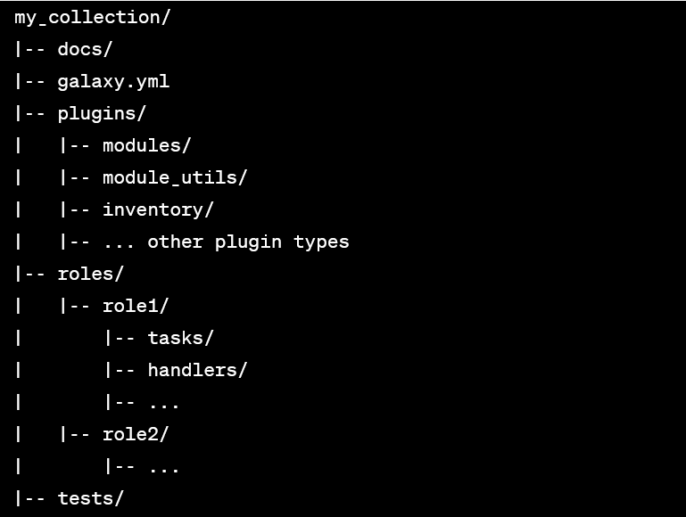

Ansible Galaxy: Ansible Galaxy is a platform and online community where you can find, share, and distribute Ansible content. This content typically includes roles, modules, and collections that can be used to automate various tasks in your IT infrastructure. Ansible Galaxy provides a centralized location for sharing and discovering automation content, making it easier for Ansible users to collaborate and leverage each other's work.

Ansible Handler: In Ansible, a handler is a special kind of task that is only run if one or more tasks in a play have made changes. Handlers are typically used to trigger actions such as restarting a service or reloading a configuration file after changes have been made to the system.

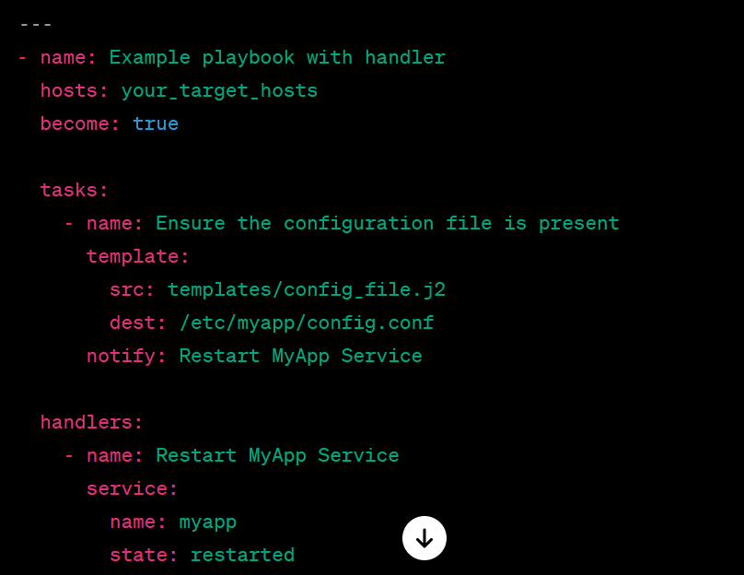

Ansible facts: In Ansible, facts are pieces of information gathered from target hosts during the execution of a playbook. Ansible collects a variety of system-related information, such as network interfaces, operating system details, hardware information, and more. Facts are automatically collected and made available to you as variables that you can use within your playbooks.

